Requirements for EVS tree

- The tree should be displayed in the right frame of the EVS tree window
- The tree shall be able to change skins as requested
- Clicking the folders should open and close them and allow the user to navigate the tree
- User should be able to select items by clicking on them (terms need to be hyperlinked)
- The user can perform a search for items by entering a search term in the text input field in the top left corner of the EVS tree window.
- The search should return items are contained in the tree and that match the entered word / phrase.
- Search needs to work for phrases (multiple words with spaces) (missing feature)
- The search needs to work for partial terms.
- The search should also return results when synonyms of terms contained in the vocabulary are entered.
Examples from mouse anatomy tree:
user enters “voicebox” – search returns “larynx”
user enters “throat” – search returns “pharynx”
user enters “breast” – search returns “mammary gland”
- The search results displays two options: First is a hyperlinked display of the term which, when selected, pops up a confirmation screen and redirects all the way back to the caMOD screen with the term filled in. For example, search for heart and the results will display Heart_MMHCC and Muscle_Striated_Cardiac_MMHC. The user should be able to select one of these results as a final selection, confirm the selection, and be returned to the caMOD application search criteria screen directly. The second displayed result is the “Show in Datatree” button that exists currently.
- Each item should only be listed once in the list of search results (similarity of items is determined by concept uid). If the search finds the same item in multiple locations of the tree the “Show in Datatree” button should open the tree in multiple locations and highlight the terms.
- The “Show in Datatree” button jumps to the highlighted term, but if the list is too long the user must scroll down to see the highlighted term. The application should scroll down on its own and focus on the highlighted term as it did in the previous version of EVSTree. If the same term exists multiple times in the vocabulary the tree should jump to the first term.
- If the search does not return results a note informing the user should be displayed. “No matching terms found”

Specifics for trees on search pages
- User is allowed to select all levels of tree
- When user selects a concept which has subconcepts; the query should be performed for the concept itself and its subconcepts

Specifics for trees on submission pages
- The user should not be allowed to select the top level node (e.g. organ system in anatomy trees) and the superconcept of the organ system which would be the root node
- When the user selects an item from the tree the concept code and name of only the selected item should be inserted in the database
- The user should be presented with an option to enter a new term if the vocabulary does not supply the required term. This is especially important for the disease vocabularies. This feature will be implemented for all other vocabulary trees in the next release.
After performing a search the user should be presented with a button (or other means) to open a text input field. The button to open the text field should be displayed after query has been performed and no results are returned.

Specifics for property file configurations
- All configuration properties must work, be tested and documented.
- All trees must toggle between Preferred Name and Display Name using the “usePreferredName” tag. The displayName will be used for all vocabularies but the functionality to toggle must work.

 | Name | Preferred Name | Display Name
Mouse organ | Heart_MMHCC | Heart (MMHCC) | Heart
Rat organ | Rat_Heart | Rat Heart | Heart
Zebrafish organ | heart | heart | heart (Pharyngula:Prim-5 to Adult)
Human organ | Heart | Heart | Heart
Mouse disease | Mouse_Endocrine_Gland_System_Disorder | Mouse Endocrine Gland System Disorder | Endocrine Gland System Disorder
Rat disease | Rat_Endocrine_System_Neoplasms | Rat Endocrine System Neoplasm | Endocrine System Neoplasms
Zebrafish stages | Blastula:128-cell | Blastula:128-cell | Blastula:128-cell
Staining Method | Wright-Giemsa_Staining_Method | Wright-Giemsa Staining Method | Wright-Giemsa Staining Method

- The Zebrafish vocabulary trees (maybe all trees) must toggle between isa and partOf relationships using the isaFlag tag.
- All trees shall toggle between onlyLeaf = true and false. If onlyLeaf is false the depthLevel must be set to -1 (? **Ulli will add to this)

APPENDIX A – Screen shots of vocabulary trees
Zebrafish developmental stages:
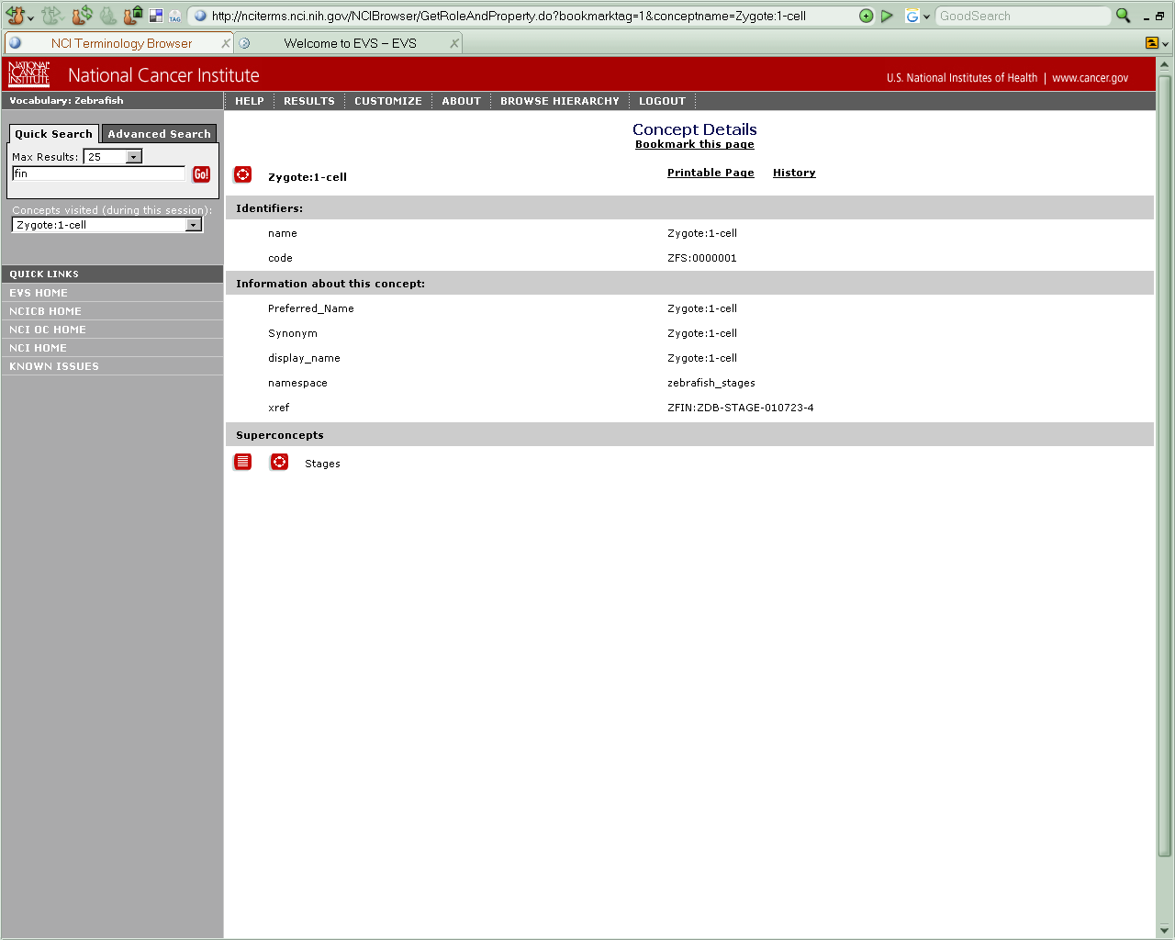

Zebrafish anatomy:
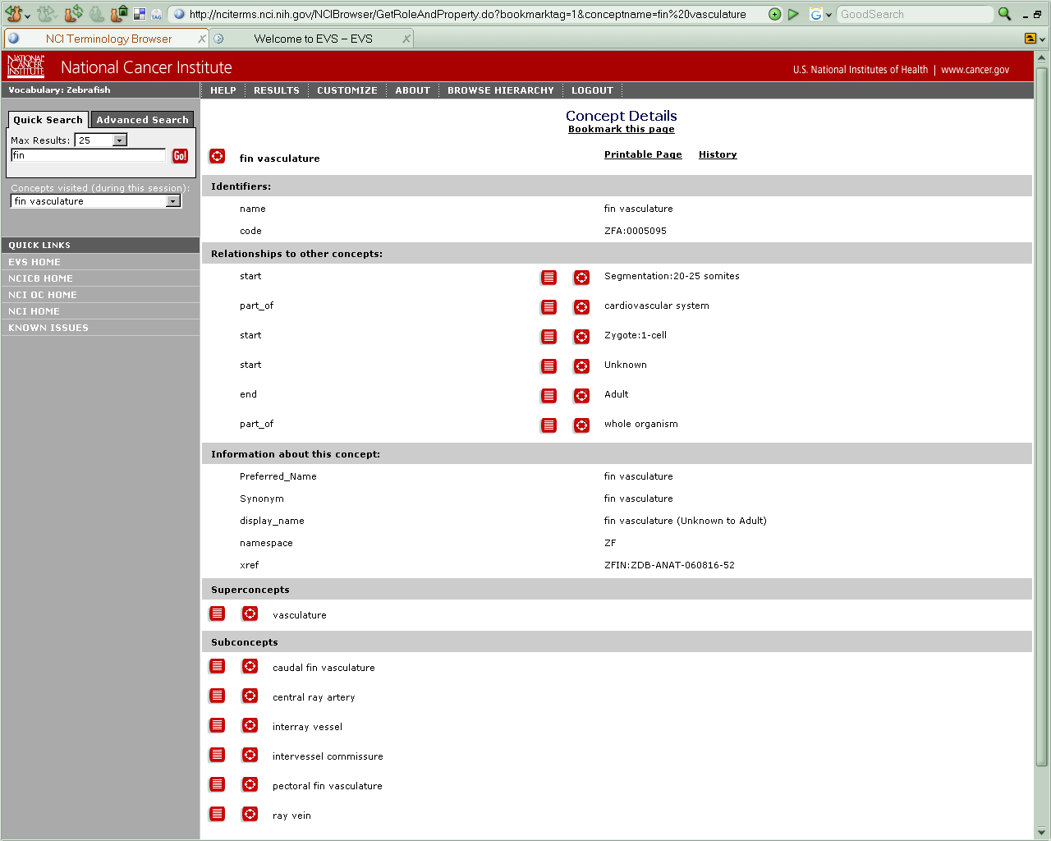
Staining Method:
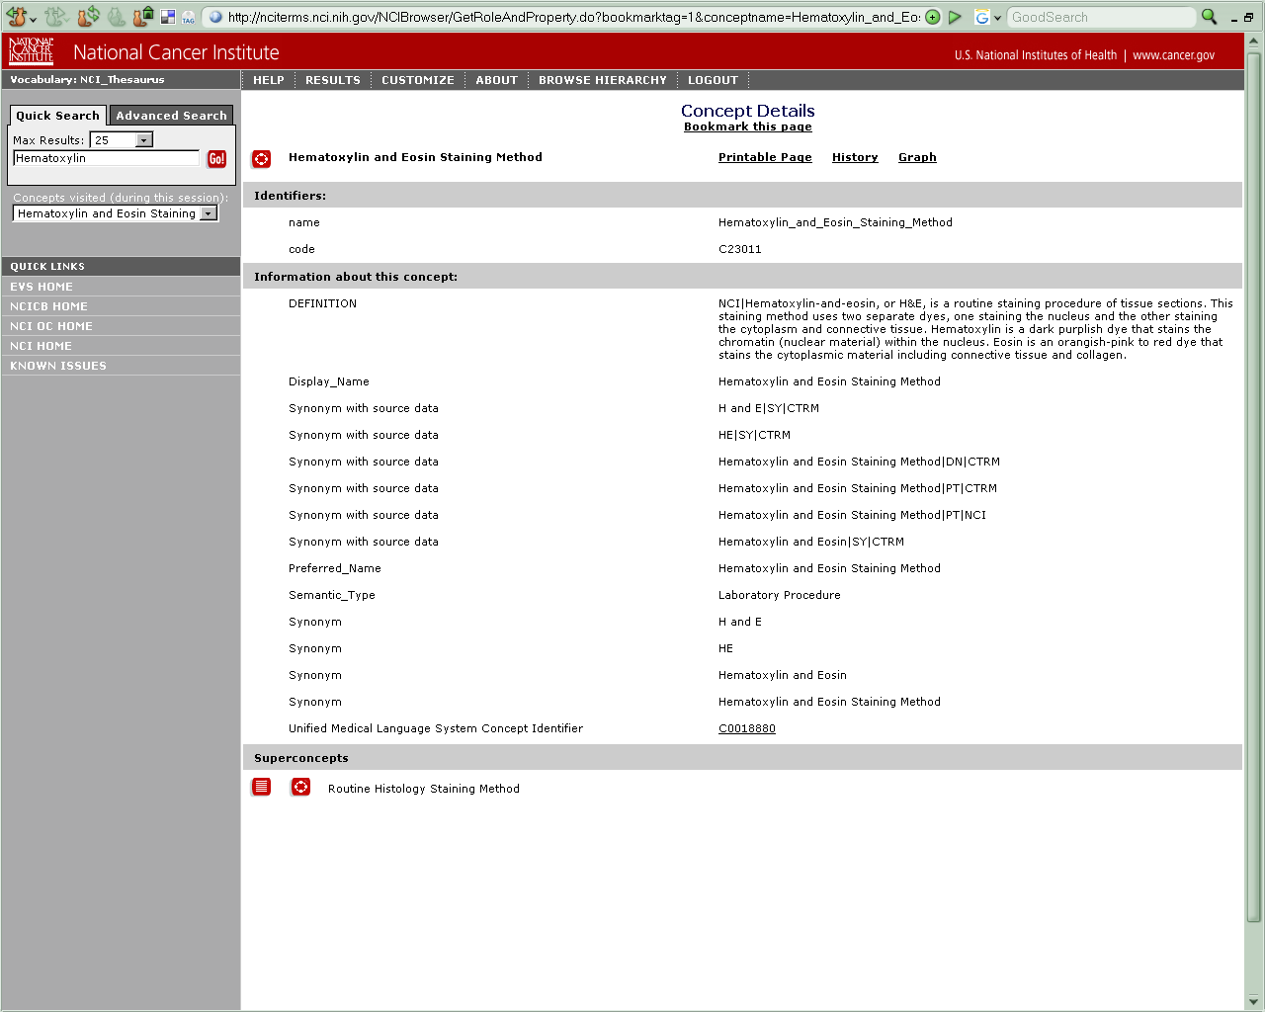

Rat Anatomy:
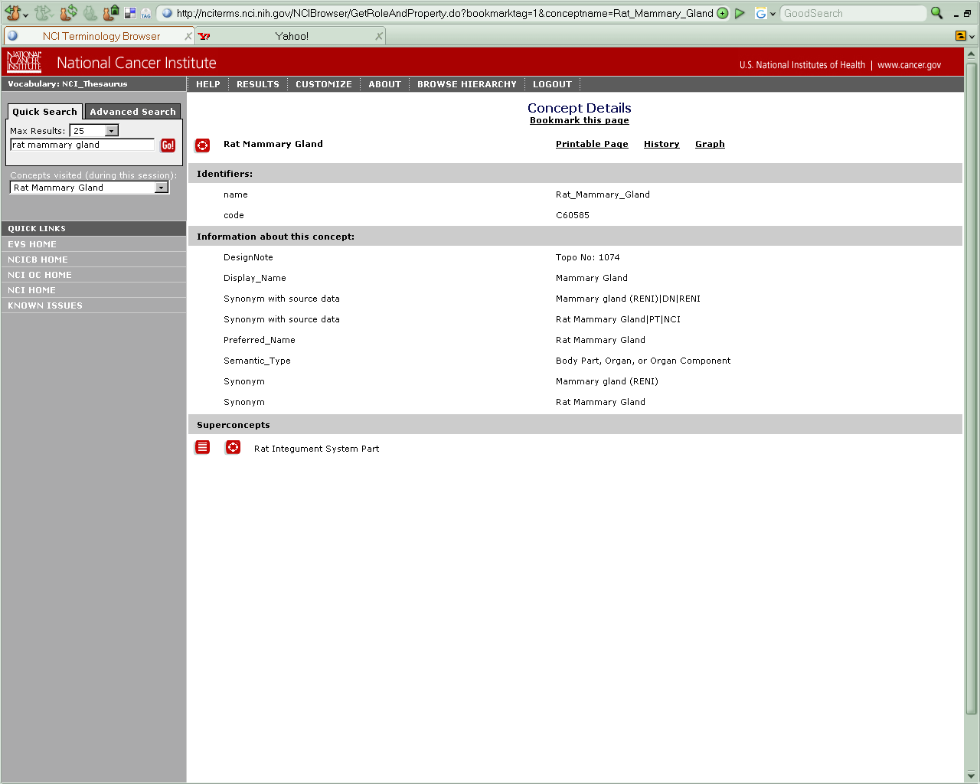
Rat Disease:
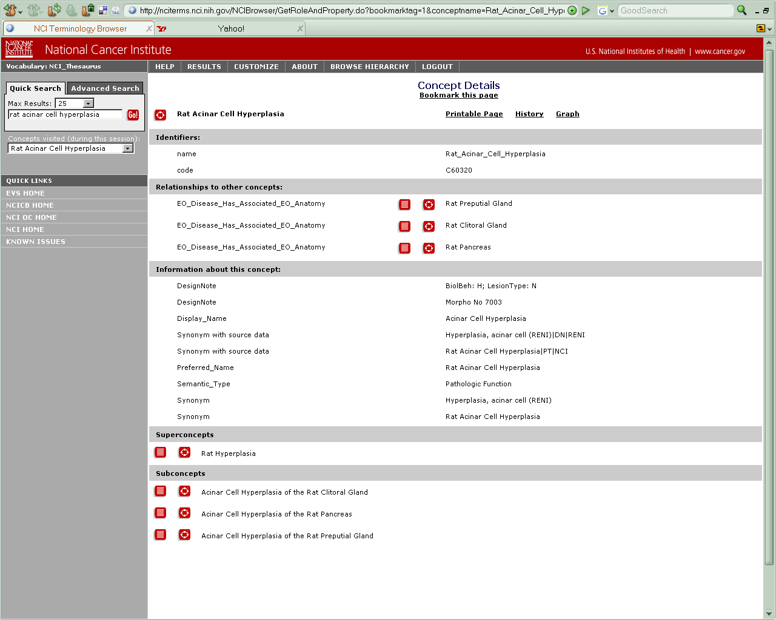
Mouse Anatomy:
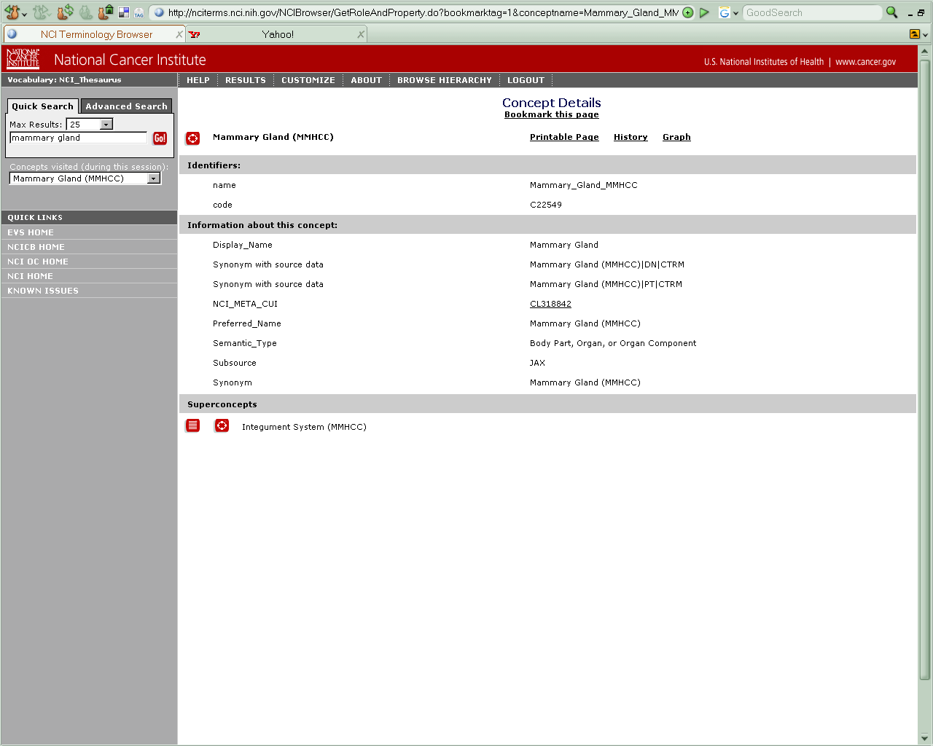
Human Anatomy:
